User Survey Content

# First Time Assessment

* Should we add a link to the CDC Coronavirus Self-Checker bot?
* Where are you located?
  + < city, region, country> - zip code <auto-generated>
  + Prefer not to say
* What is your age?
  + Younger than 2 years old
  + 2-4 years
  + 5-9
  + 10-18
  + 19-29
  + 30-39
  + 40-49
  + 50-59
  + 60-64
  + 65-69
  + 70-79
  + 80+
* What is your gender?
  + Male
  + Female
  + Other
* Have you traveled outside your home country in the last 14 days?
  + Yes
  + No
  + Prefer not to say
* To the best of your knowledge, have you been in close contact with anyone who has a confirmed case of COVID-19?
  + Yes
  + No
  + Prefer not to say
* Have you received a flu vaccine in the last 6 months?
  + Yes
  + No
  + Prefer not to say
* Have you been tested for COVID-19
  + Yes <if checked, ask date of the last test. And result – Positive, Negative, Pending, Inclusive, prefer not to say>
  + No
* Do you have any of the following conditions?<add question about medical conditions/background>
  + Diabetes
  + Cancer
  + Pregnancy
  + Asthma or chronic lung disease
  + Heart, kidney, or liver conditions
  + Weakened immune system
  + None of these
* Do you have any of the following symptoms?
  + Fever <if checked, ask the highest temperature>
  + New or worsening cough
  + Muscle or body aches
  + Shortness of breath
  + Sore throat or itchy/scratchy throat
  + Feeling more tired than usual
  + Chills or shivering
  + Runny/stuffy nose or sneezing
  + Nausea or Vomiting
  + Headache
  + Abdominal pain
  + Diarrhea
  + Lost sense of smell and taste
* What day did you start feeling ill?

# Daily Survey

The default question could base on how the user responds in the first assessment. For example, if the user select 4 symptoms, say fever, cough, sore throat, headache, could we only show those 4 by default with an option to add new symptoms?

* + 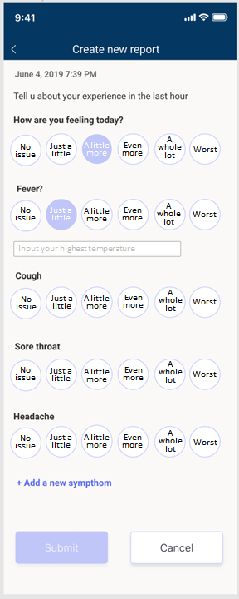

Here is the Full table for symptom and values: (we may reduce)

Final version:

* feelingRating:0 - no answer, 1-6 for rating
* feverChillsRating:0 - no answer, 1-6 for rating
* temperature: real number, Fahrenheit
* coughRating:0 - no answer, 1-6 for rating
* shortnessOfBreathRating: 0 - no answer, 1-6 for rating
* soreThroatRating:0 - no answer, 1-6 for rating
* fatigueRating:0 - no answer, 1-6 for rating
* nauseaRating:0 - no answer, 1-6 for rating
* abdominalPainRating:0 - no answer, 1-6 for rating
* diarrheaRating:0 - no answer, 1-6 for rating
* Other Free Text, 256 chars

Reference:

<https://www.nejm.org/doi/full/10.1056/NEJMoa2001191>

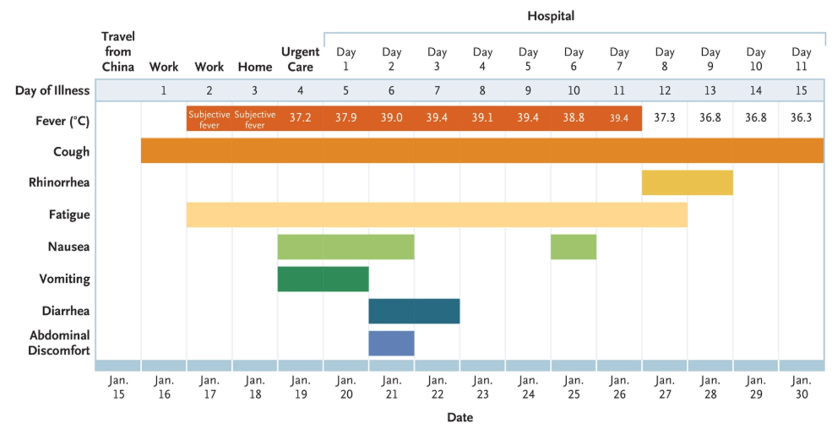

Rate any pain in your throat? Not at all [1 –10]

How tired are you? Not at all [1 –10] Always

How often do you find yourself out of breath? Never [1 –10] Always

If you feel that you are NOW symptomatic, what was the date of the onset of symptoms? []

Have you been tested for COVID-19?

No / Yes

Date of last test

Positive / Negative / Pending

Current temperature (opt if <99)

Current location (geo-location)